**ISSUE 01 – Saved and Unsaved Profile icons**

These heart icons are incorrect icons.

The person icon with (+) and (-) sign is the correct icon. The correct icon appears when saving profile from “listing page”. Incorrect icon appears when saving profile from “profile page”. This is new issue – it was working fine before

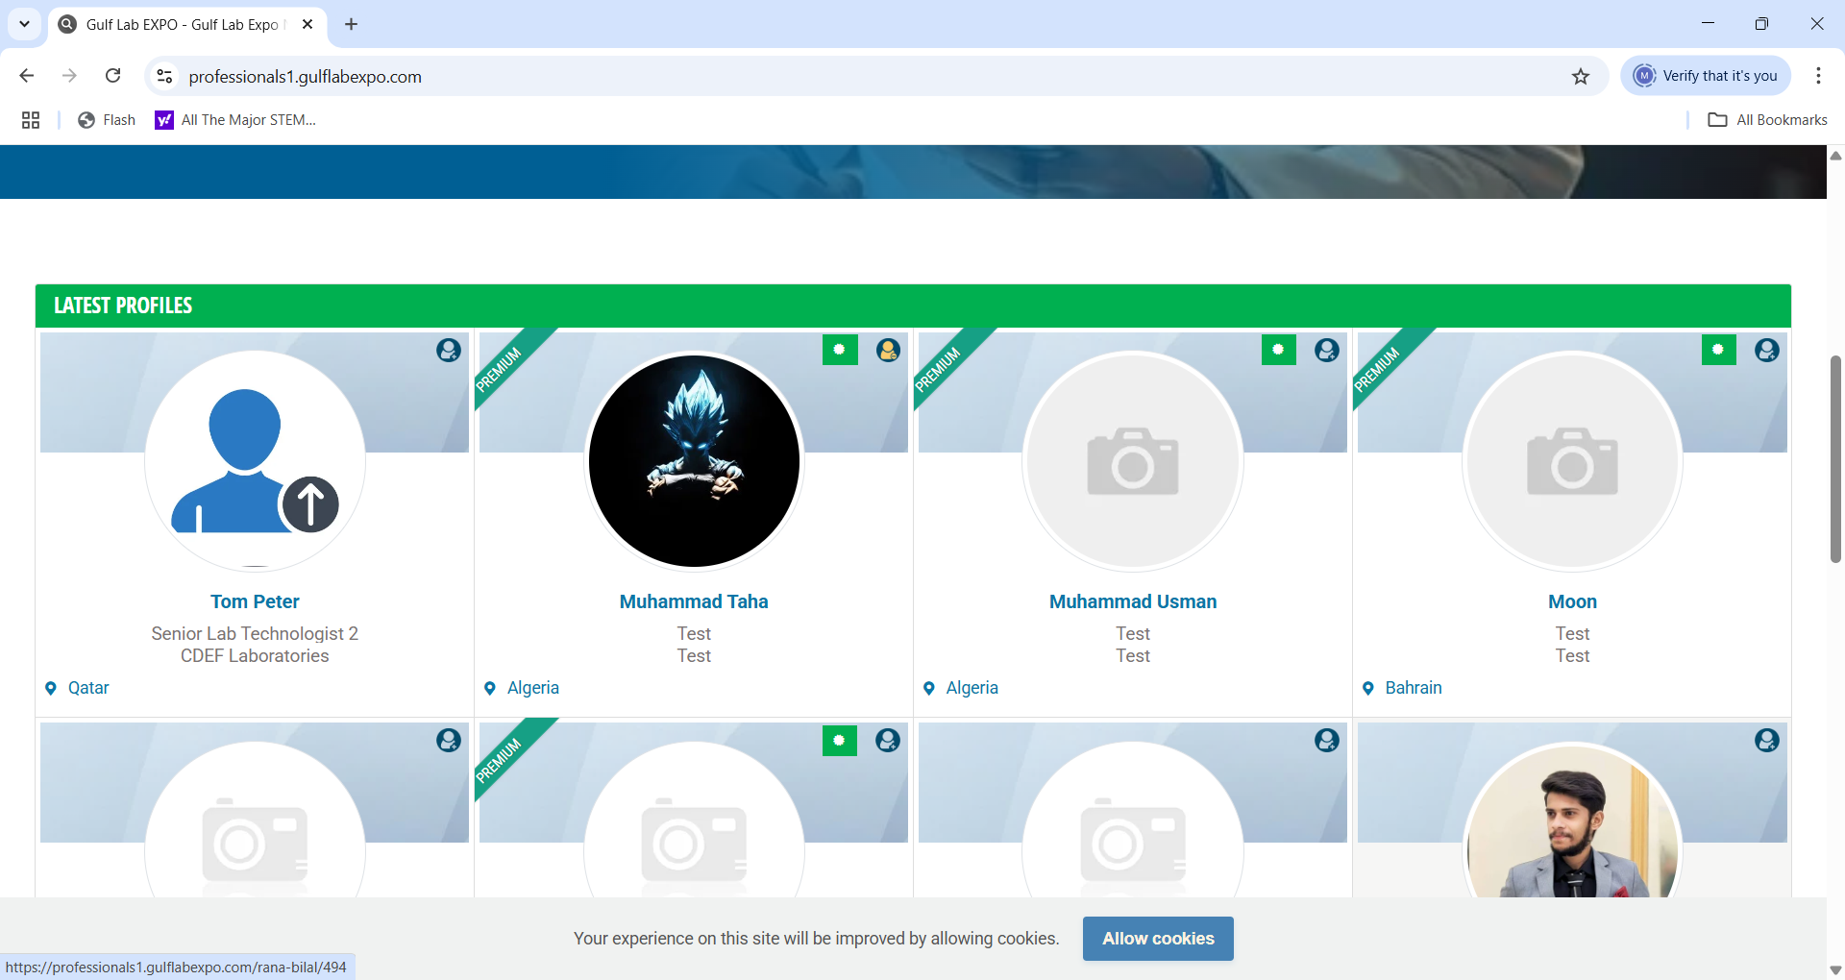

ISSUE 02 -New issue – **Country field is not appearing in update mode.** On update, country and city is removed from the profile. When country field is not there, the website is detecting the location of the visitor and offering city names for that country.

In this example, I had selected Oman as the country and Muscat as the city when creating the profile. In update form, there is no country field. In the city field, I am unable to type Muscat as it is recognizing Qatar as the country where I am located and only giving me options to type cities of Qatar. The issue had been fixed by Bilal and both country and city field was appearing with data (not empty) in update form. Now issue is back.

**ISSUE 03 - Linkedin Profile field not appearing on update**

Profile got updated and saved without Linkedin URL

**Minor updates**

This page comes up when there are no results

In first line - Change “MENA clinical lab industry” to “MENA medical research community”

Delete third line “connect with buyers, sellers, and other lab industry experts”

Remove white space on top and delete title “FAQ” and the first line “Frequently Asked Questions”

Remove the word “new” from the warning.

Remove the word “Global!” from message start

Email address update is not allowed in the application. Therefore, we need to add a message

On clicking Update button, message should appear “To change your account email address, please send email to info@menamedicalresearch.com from your registered email address.”

**Email text changes**

Heading and copyright text needs to change from Gulf Lab EXPO to MENA Medical Research

Heading and copyright text needs to change from Gulf Lab EXPO to MENA Medical Research

Heading and copyright text needs to change from Gulf Lab EXPO to MENA Medical Research

Heading and copyright text needs to change from Gulf Lab EXPO to MENA Medical Research

Change text

In first paragraph – change “MENA Clinical Lab industry” to “MENA Medical Research Community”

Bullet No 1 – change to “Members can view your profile and contact you through LinkedIn”

Bullet No 3 – change to “You can find members with similar research interests”

Bullet No 4 – “You can send LinkedIn connection request directly to other members”

Bullet No 5 – delete bullet 5

